Long Method
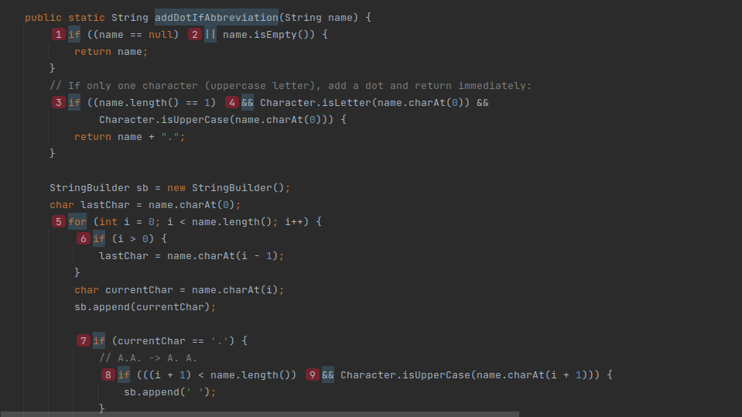
Located at src/java/org/jabref/model/author.java line 39 the method addDotIfAbbreviation
Problem: it’s 82 lines long and has a cognitive complexity of 41 (way above the default value of 15)
Refactor Proposal:
Split into several methods to reduce complexity and length. The inner code on the outer for (lines 52 to 117) could be moved to a new method that takes the input chars (currentChar and lastChar) and the String Builder. The same could then be done for the inner for loop (lines 99 to 116)
Long Class
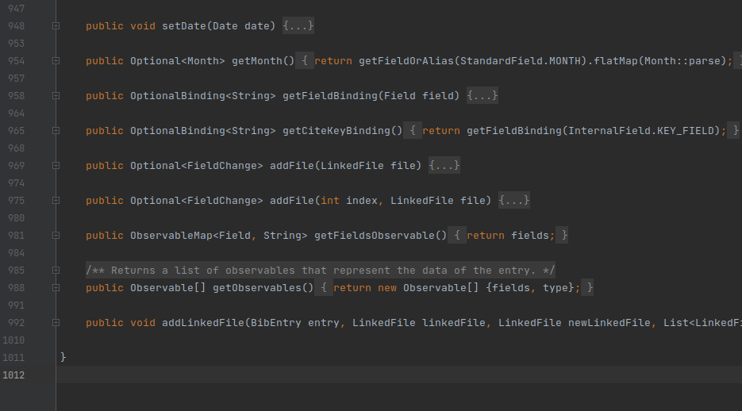
Located at src/java/org/jabref/model/entry/BibEntry.java
Problem: Class spans over too many lines, over 1000, and provides too many methods
Refactor proposal:
Create a new class BibEntryFields that stores the fields for the BibEntry and provides all related functionality, allowing to remove responsibility and methods from BibEntry.java
Duplicated Code
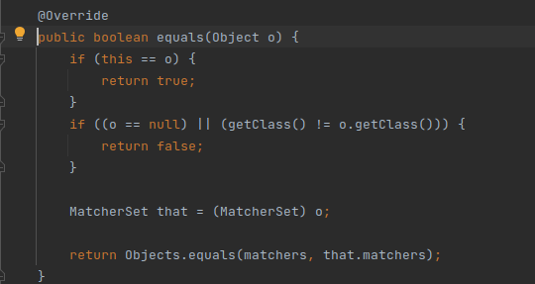
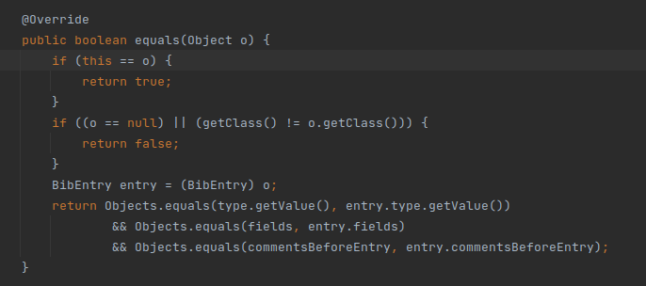
Location: src/main/java/org/jabref/model/search/matchers/MatcherSet.java, src/java/org/jabref/model/entry/BibEntry.java and several other places
Problem: This segment of the equals method has similar duplicates many times across the code. This could be an issue if another generic case needs to be considered which would alter the result or allow a faster matching.
Refactor Proposal:
Extract the common part of the method to a static method and pass the non common part of the verification as a lambda

